Dator- & telekommunikation

*Föreläsning 3*

Mobilnät och satellitnät

* För att klara av bristen på kapacitet
  + ⇒ Multiple access och kanalisering (uppdelning av kanaler (FDMA, TDMA eller CDMA), se F1)

# Mobilnät

* Kommunikation mellan rörliga enheter / rörliga och fasta enheter
* Baseras på indelning i celler
* Radioskuggor, områden där celler inte täcker
* Finns även överlappning
* Celler ritas grafiskt upp som hexagoner
  + Finns begränsat antal frekvenser (180 st)
  + Dessa återanvänds och multiplexeras
    - Detta är möjligt eftersom den mobila signalen dämpas väldigt fort



* GSM - Global System for Mobile communication
  + Använder **2st 25Mhz** band **duplexkommunikation** (**124** **kanaler**)
  + Varje kanal är **200kHz**
  + Finns guard band mellan kanaler
  + Har ett visst frekvensband
  + 1 reverse-band och 1 forward-band
    - För att kunna prata i mun på varandra, till skillnad från walkie-talkies
* 3G
  + Snabbare och högre frekvenser än 2G
    - Högre frekvens ⇒ Kortare räckvidd
    - Fördel i städer för då kan vi lägga våra “celler” närmare varandra och återanvänding av frekvenser kan ske effektivare/snabbare
    - Nackdelen med dessa är “ute på landet”
  + Finns flera standarder
* UMTS - Universal Mobile Telecommunications System
  + Utveckling av GSM
  + Datan paketbaserad, talet analoga signaler
* 4G
  + Högre hastigheter
  + Helt paketbaserad (fullständigt digitaliserad)
    - Både data och tal
    - Rösten/tal omvandlas via PCM
* 5G
  + Ännu högre hastigheter
  + Lägre fördröjningstider jämfört med i 4G
    - Ska inte få ta lång tid från när vi skickar signalen tills den kommer fram
  + Ska kunna hantera flera uppkopplingar samtidigt

# Satelitnät

* Finns olika tekniker för hur satelliter skickas iväg (olika orientering)
  + Cirklar runt ekvatorn
  + Cirklar kring polerna
  + (Lutad cirkling)

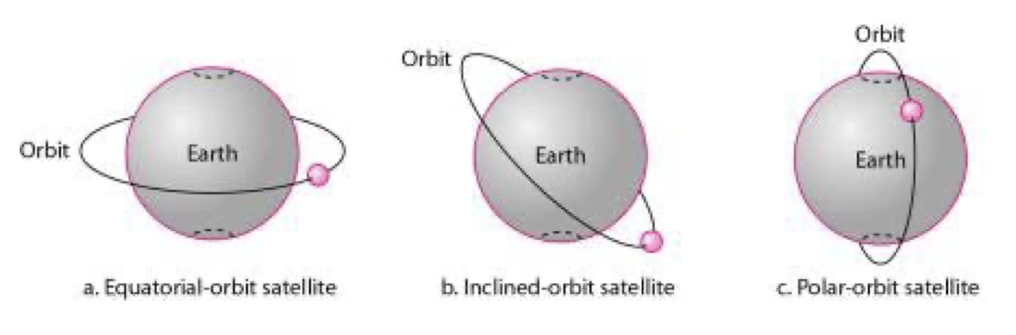

* Kepplers 3:e lag gäller för satelliter i bana
  + T = k*r^1.5
    - ⇒ Omloppstiden = konstant*r^1.5
    - Omloppstid [sekunder]
    - r [km] - medelavstånd på cirkulerande enhet ()
    - k - konstant
* 3 huvukategorier av satelliter
  + GEO - geosynchronous earth orbit (geostationärsa satelliter)
  + MEO - medium earth orbit
  + LEO - low earth orbit
  + Uppdelningen i de tre typerna beror på “Van-Allen-bältena”

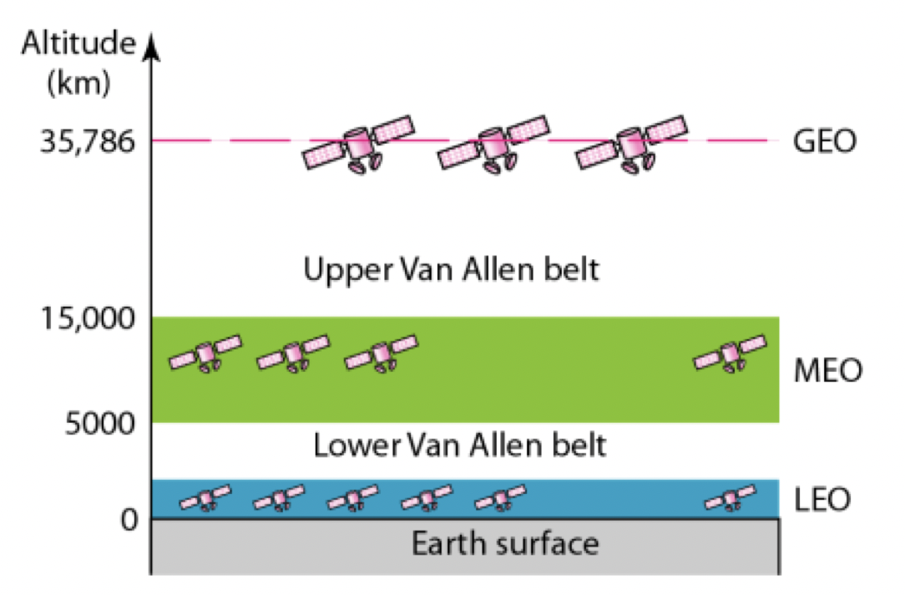

# Mobilitet

### **Mobilitet: Vad är mobilitet** (Spektrum, sett från nätverkets perspektiv)

* **Ingen** **mobilitet** - mobil trådlös uppkoppling, genom en och och samma accesspunkt
* **Mitten** - Användare förflyttar sig mellan flera accesspunkter, men stänger av förbindelse mellan varje förflyttning (ex. en **laptop**)
* **Hög** **mobilitet** - Mobil användare som passerar genom flera accesspunkter, samtidigt som uppkoppling upprätthålls

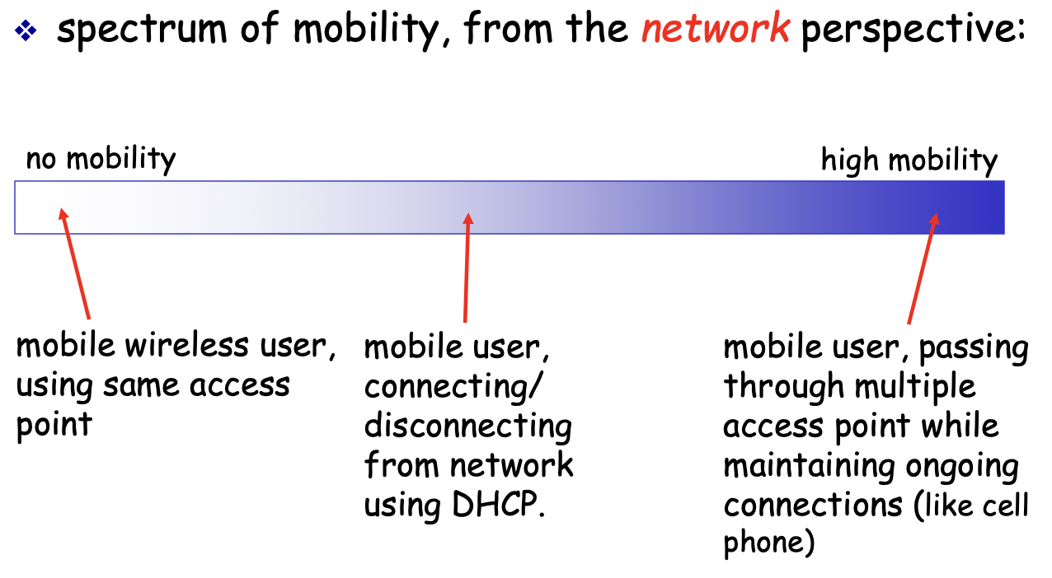

### Mobility: Vocabulary

| **(1) Home network** - Permanent home of mobile | |
| --- | --- |
| Permanent address | Address in home network, can be used to reach mobile |
| Home agent | Unit that will perform mobility functions on behalf of mobile, when the mobile is remote |
| **(2) Visited (foreign) network** - Network in which mobile currently resides | |
| Permanent address | Remains constant |
| Care-of-address (c/o) | Address in visited network |
| Foreign agent | Unit in visited network that operforms mobility functions on behalf of the mobile |
| **Correspondent** - Unit that wants to communicate with the mobile | |



### Mobility: Approaches

* Let **routing** handle it: Router advertise the permanent address via usual routing table exchange
  + NOT SCALABLE!!!!!
* Let **end-systems** handle it
  + 1. **Indirect** routing: communication from correspondent to mobile goes through home agent then forwarded to remote
  + 2. **Direct** routing: correspondent gets foreign address of mobile, sends directly to mobile
* OBS! Both **indirect** and **direct** **routing** supposes that a **correspondent** wants to send datagrams to a **mobile** **node** (correspondent → mobile node).

### Mobility: Registration (with home network)

| **1.** | Mobil kontaktar **foreign** **agent** och frågar om IP-adress, när den går in i **visited** **network**. |
| --- | --- |
| **2.** | **Foreign agent** kontaktar **home** **network** (genom WAN) |
|  | |

### (1) Mobility: Mobility via indirect routing

| **(1) Indirect Routing = Triangle routing** | |
| --- | --- |
| * “**Triangelkommunikation**”: correspondent → home network → mobile * Ineffektivt när correspondent och mobil är i samma nätverk * Mobil använder 2 addresser   + Permanent   + Care-of-address * “Foreign agent”-funktioner kan göras av mobilen själv * **Goal**: **Correspondent** addresses packets to mobile node’s **permanent** **address** | |
| **1.** | **Correspondent** routes datagrams to the mobile node’s **home** **network.** |
| **2.** | **Home** **agent** intercepts packets and **forwards** these to the **foreign** **agent** (through the WAN). |
| **3.** | **Foreign** **agent** receives packets and finally forwards these to the **mobile** itself. This is executed in 2 steps   1. Datagram is forwarded to the **foreign** **agent** using the mobile node’s **care** **of** **address…** 2. then foreign agent forwards the packets to the **mobile** **node** |
|  | |

| **Accommodating mobility with Indirect Routing** | |
| --- | --- |
| * Suppose mobile user moves to another network * Mobile will register with new **foreign** **agent** * New **foreign** **agent** registers with **home** **agent** * **Home** **agent** update **care-of-address (c/o)** for mobile * ⇒ packets continue to be forwarded to mobile (but with new care-of-address) | |

### (2) Mobility: Mobility via direct routing

| **(2) Direct Routing** | |
| --- | --- |
| * Overcome “triangle routing problem” | |
| **1.** | **Correspondent** requests/queries **home** **agent** |
| **2.** | **Home** **agent** replies, thus letting **correspondent** receive **foreign** **address** of mobile (c/o) |
| **3.** | **Correspondent forwards** datagrams to **foreign** **agent** through WAN. |
| **4.** | **Foreign agent** forwards datagramto **mobile. Mobile** laterrepliestothe **correspondent,** meaningithasgotadirectconnectionwiththecorrespondent. |
|  | |

| **Accommodating mobility with Direct Routing** | |
| --- | --- |
| * **Anchor** **FA** (foreign agent) in **first** **network** * Data will always be routed to the anchored FA * When mobile moves: new FA arranges to have data forwarded from old FA (**chaining**) | |
|  | |

# Mobile IP

### **Mobile IP Standard** (3 main components)

| *#* | *Component* | *Description* |
| --- | --- | --- |
| **1.** | **Agent discovery** | Mobile IP defines protocols used by a **home** **agent** or **foreign** **agent** to advertise its services to **mobile** **nodes** and vice versa. |
| **2.** | **Registration with the home agent** | Mobile IP defines the protocols used by the **mobile** **node** and/or **foreign** **agent** to **register** and **deregister** **c/o** using a mobile node’s **home** **agent**. |
| **3.** | **Indirect routing of datagrams** | Mobile IP also defines the **manner** in which datagrams are **forwarded** to **mobile** **nodes** by a **home** **agent**. |

### 

### Handling mobility in cellular networks

| **Responsibilities of home and visiting network (Mobile IP)** | | |
| --- | --- | --- |
| **1.** | **Home network** | The cellular provider with which the mobile user has a subscription (ex. Telenor, comviq, etc.)  Contains:   * **HLR (Home Location Register)** - databas som innehåller permanent mobilnummer, personlig data, subscribe:rns nuvarande position etc. * **MSC (Mobile Switching Center)** - A switch that is contacted by the **correspondent** when a call is placed to a mobile user. |
| **2.** | **Visited network** | Contains:   * **VLR (Visited location register)** - databas med en ingång för varje användare i nätet just nu. * VLR is usually co-located with a **MSC (Mobile Switching Center)** |
| * In practice, a provider’s cellular network will act as a **home** **network** for the **subscriber** and as a **visited** **network** for a **mobile** user whose subscription is with a **different** **provider**. | | |
|  | | |

**Indirect routing to mobile**

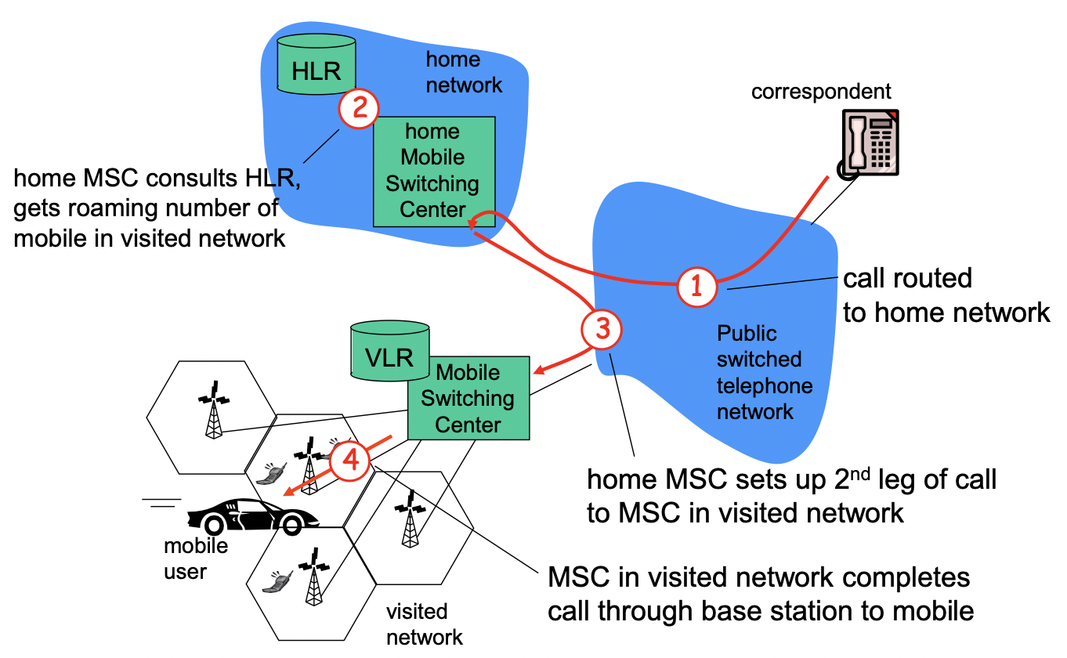

* 5 sista slides i F3

**Handoff with common MSC (Mobile Switching Center)**

| **Fundamentals** | |
| --- | --- |
| * Handoff is initiated by old **BSS** | |
| **Goal** | Route call via new base station (without interruption) |
| **Reasons**  (examples) | * **Stronger** **signal** to another **BSS** (Basic service set) * **Load** **balance** - **Free** **up** channel in current **BSS** |

| **How handoff works** | |
| --- | --- |
| **1.** | old BSS informs MSC of impending handoff, provides list of 1+ new BSSs |
| **2.** | MSC sets up path (allocates resources) to new BSS |
| **3.** | new BSS allocates radio channel for use by mobile |
| **4.** | new BSS signals MSC, old BSS: ready |
| **5.** | old BSS tells mobile: perform handoff to new BSS |
| **6.** | mobile, new BSS signal to activate new channel |
| **7.** | mobile signals via new BSS to MSC: handoff complete. MSC reroutes call |
| **8.** | MSC-old-BSS resources released |
|  | |